Comprehensive Creative Technologies Project: Simulating the Effects of Climate Change on a Game Environment

**Author Name**samuel3.carr@live.uwe.ac.uk  
Supervisor: Mr Sean Butler

Department of Computer Science and Creative Technology

University of the West of England  
Coldharbour Lane  
Bristol BS16 1QY

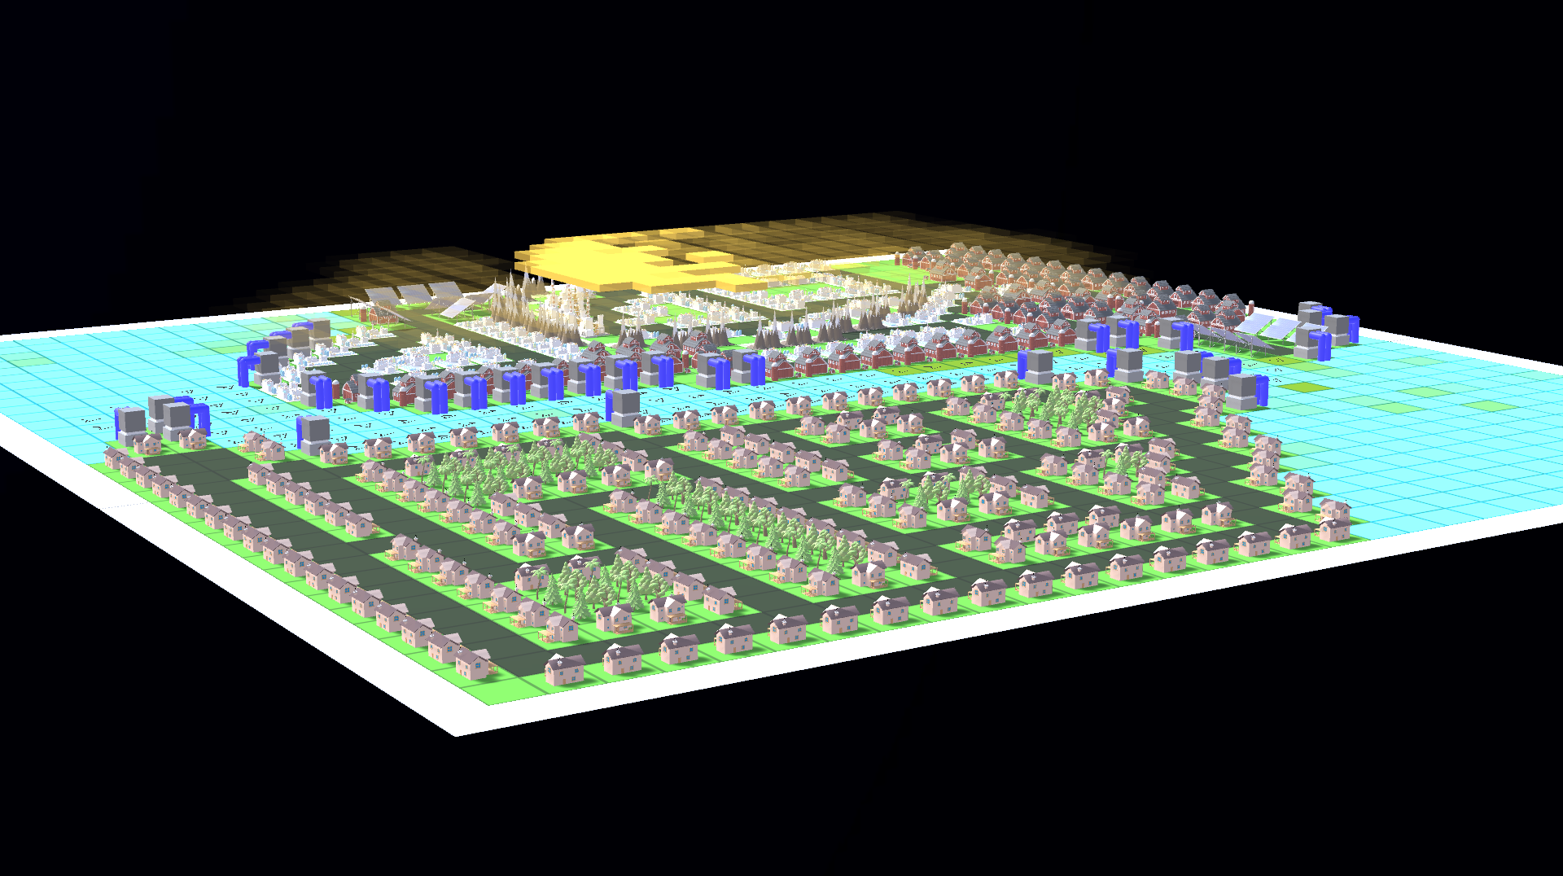

**Abstract**

This project is a simulation that aims to teach the user about how climate change can affect the environment, the city, and its population. This was achieved through the medium of a game where the user controls a city and their decisions have an impact on the environment around them. If polluted water is drunk, the population becomes ill and is unable to work, reducing productivity and overall gain of the city. Food production starts to fall, and the city becomes unable to support the local population. If pollution is left in the air, food production falls due to the Carbon-Nitrogen cycle, solar panels produce less electricity due to smog, and the population becomes ill from unclean air.

**Keywords**: Climate Change, carbon, nitrogen,

**Brief biography**

**How to access the project** (not included in word count)

**1. Introduction** 278/400 words

Climate Change is an issue that affects everyone and nearly every aspect of daily life (Perry, 2007), and this project aims to simulate its effects on an environment within a game. For this project, a city-builder like design was chosen to give the user a more direct impact on the output of toxic and greenhouse gasses and how it affects their city.

The project originally started as a pure simulation, with the user being able to input values into a system and watch the effects over time. The decision was made to change it into a city builder to have the pollution effect something the user has built to make it more engaging and educational.

The project explores how pollution will affect a population within a city and its components, such as farms, solar panels, and water sources. An example of how the pollution will affect the population is if the water becomes contaminated, and is then fed into the cities water system. This will cause residents to become ill and unable to work, affecting work efficiency and food production in the farms. This is indicative of Flint, Michigan (Zahran, 2018) and the Legionnaires disease outbreak that occurred due to the local government beginning to supply the residents with polluted water from the river (Denchak, 2018).

The project aims to educate about the effects of climate change in an engaging way through a medium that is accessible to as many people as possible.

Project Objectives:

* Simulate effects of climate change in a city environment
* Educate users on how pollution will affect a city

Deliverable:

* A city-builder game that simulates climate change and its effects on the city built.

**2. Literature review** 484/600w

Literature review – 2.1 – Rice and Wheat production

An increase in global temperatures and CO2 levels have raised numerous concerns about food production and the consequences of climate change on farms. In a study conducted in Bangladesh, Amin (2015) found that certain types of rice, such as Aman Rice, became greatly influenced by climate conditions when rainfall amounts are changed and exposure to sunlight, along with temperatures, is both increased and decreased. These reduce both the yield and cropping area of the Aman rice, significantly affecting the total production of that type of rice.

However, in contrast, Aman rice is positively affected by humidity in terms of both cropping area and yield. Other types of rice, such as Boro rice, and also wheat are also affected by an increase in maximum temperature, however, both minimum temperature and sunlight exposure seemed to increase the yield of Boro rice significantly.

Literature review – 2.2 – Water pollution

Water pollution is harmful to both humans and the environment, as it is a prime breeding ground for diseases such as Legionella (Zahran, 2018) and Cholera (Frerichs, 2021) where several pandemics have taken place due to the deadly disease, and only being linked to dirty water in 1854 by Professor John Snow. These diseases are caused by the consumption of infected water, usually caused by pollution or dirty water sources. These diseases can be deadly to human, but water pollution also affects the aquatic animals and the ecosystem, with some fish becoming unable to find food or dying from illness, or plants unable to photosynthesise due to pollution blocking sunlight

(See Fig. 1 below).

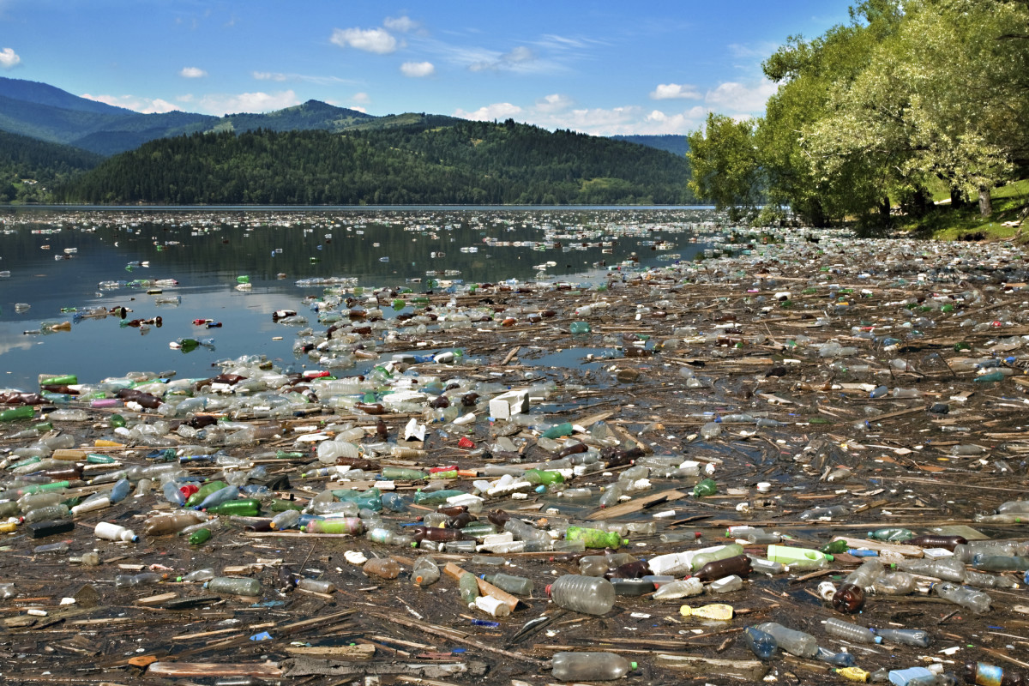

**Fig 1**: Pollution in a Lake (Sourced from History.com)

The vast majority of sea life that people rely on is also affected, with one being coral reefs (Gibson et al., 2008) and the bleaching effect climate warming is having on them, where the corals slowly start to lose colour and eventually die, leaving fish without shelter or reliable food sources and subsequently destroying the ecosystem.

Literature review – 2.3 – Wildlife & Habitation

Humans rely on animals and wildlife for a large percentage of our agricultural resources (Ritchie, 2017) at around 80%. During 2019 and into the start of 2020, an Australian wildfire during the wildfire season grew out of control, leaving a devastating trail of burnt forests and fields, and killing or displacing nearly 3 billion animals (Slezak, 2020). Many links have been made about the start of the bushfires and why they spread so quickly to climate change and its effects on Australian weather. On average, the “fire season” in Australia has been 1C hotter than usual and set a new record of 41.9C (BBC, 2019)

The wildfires also released an estimated 300 million tonnes of CO2 into the atmosphere (Lee, 2019), which can contribute to global warming and other issues, such as around 450 people died because of smoke emissions from the bushfires (Hitch, 2020).

**3. Research question** 250w

Research Question - 3.0 – Overall question

How can simulating Climate Change affect a game Environment?

Research Question – 3.1 – Water

When trying to answer the overall question, it can be split into smaller questions for each part of the project. The first will be:

* What effects will pollution have on water?

This question can also include:

* What will the effects of the polluted water be on the user?

As water is an important part of a city, furthermore water is one of the most affected aspects by climate change in the world.

Research Question – 3.2 – Agriculture

Another important section is agriculture, and how

the project can show its effects through the medium:

* How will pollution affect food growth?
* What effects will this have on the city and the player?

Food growth is essential when building a city, and keeping its populace happy, and these questions can link to the previous questions involving water pollution, as some places in the world rely heavily on fishing for food sources and in some cases, is a large part of the economy.

Research Question – 3.3 - Air

Climate change is primarily caused by air pollution from gasses like CO2,

**4. Research methods** 400w

**5. Ethical and professional principles** 350w

**6. Research findings** 600w

**7. Practice** 2500 words

**8. Discussion of outcomes** 1600

**9. Conclusion and recommendations** 300

**10. References**

Amin R, 2015, [*Effects of Climate Change on the Yield and Cropping Area of Major Food Crops: A Case of Bangladesh*](http://scholar.google.co.uk/scholar_url?url=https://www.mdpi.com/2071-1050/7/1/898/pdf&hl=en&sa=X&ei=tYiNYMa8IMKLy9YPwJeMmAE&scisig=AAGBfm0KIbQxJeMI5ialLNAzzWOM64Z80Q&nossl=1&oi=scholarr)

BBC, 2019, [*Is climate change to blame for Australia's bushfires?*](https://www.bbc.co.uk/news/world-australia-50341210)

Denchak M, 2018, [*Flint Water Crisis: Everything You Need to Know*](https://www.nrdc.org/stories/flint-water-crisis-everything-you-need-know)

Denchak M, 2018, [*Water Pollution: Everything You Need to Know*](https://www.nrdc.org/stories/water-pollution-everything-you-need-know)

Frerichs R, 2021, [*John Snow*](https://www.britannica.com/biography/John-Snow-British-physician)

Gibson R et al. 2008, [*Oceanography and Marine Biology: An Annual Review, Volume 46*](https://books.google.co.uk/books?id=h2BZZcjAdnkC&lpg=PA251&ots=0nc3NWEx1a&dq=coral%20reef%20bleaching&lr&pg=PA251#v=onepage&q&f=false)

Hitch G, 2020, [*Bushfire royal commission hears that Black Summer smoke killed nearly 450 people*](https://www.abc.net.au/news/2020-05-26/bushfire-royal-commission-hearings-smoke-killed-445-people/12286094)

Lee H, 2019, [*Bushfires Release Over Half Australia’s Annual Carbon Emissions*](https://time.com/5754990/australia-carbon-emissions-fires/)

Perry M et al., 2007 [*Climate Change 2007: Impacts, Adaptation, and Vulnerability*](https://www.ipcc.ch/site/assets/uploads/2018/03/ar4_wg2_full_report.pdf)

Ritchie H, (2017) [*How much of the world’s land would we need in order to feed the global population with the average diet of a given country?*](https://ourworldindata.org/agricultural-land-by-global-diets)

Ritchie H and Roser M, 2017 (revised 2019) [*Meat and Dairy Production*](https://ourworldindata.org/meat-production)

Slezak M, 2020, [*3 billion animals killed or displaced in Black Summer bushfires, study estimates*](https://www.abc.net.au/news/2020-07-28/3-billion-animals-killed-displaced-in-fires-wwf-study/12497976)

Zahran S et al. 2018 [*Assessment of the Legionnaires’ disease outbreak in Flint, Michigan*](https://www.pnas.org/content/pnas/115/8/E1730.full.pdf)

**11. Bibliography**

**Appendix A: Project Log** (not included in word count)

**Appendix B: Project Timeline** (not included in word count)

**Appendix C: Assets used in the Project** (not included in word count)

This is a list of project assets: all source materials used in the project. Clearly state which were produced by yourself and which were not. If not produced by yourself, include their reference, and status with regard to copyright/ creative commons licensing.

**Further Appendixes D, E … if applicable**\*(not included in word count)

* Ethics: participant info sheets, consent form, interview questions, anonymized matrices, other anonymized summaries or analyses
* Any important design documents too large to insert in the main text
* Any important code sections not already on GitHub
* Any important large tables or diagrams
* Other relevant materials

*only insert meaningful materials here, please don’t just bulk this report up. Your main text should be able to stand on its own, without relying on information contained in appendixes. Check with your supervisor beforehand.